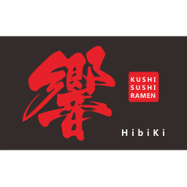

Dear Valued Customers
Please be informed that we will be closed on
Sunday 12 April, and Monday 13 April for a staff holiday. We will resume normal business hours on Tuesday 14 April.

Customers who would like to make reservations can ring our telephone number and leave messages on the answer phone or send booking enquiry via our website: www.hibiki-japanese.co.uk
We shall contact you to confirm your bookings on our return.

We appreciate your understanding and look forward to serving you when we return.
HIBIKI

